**INPUT:**

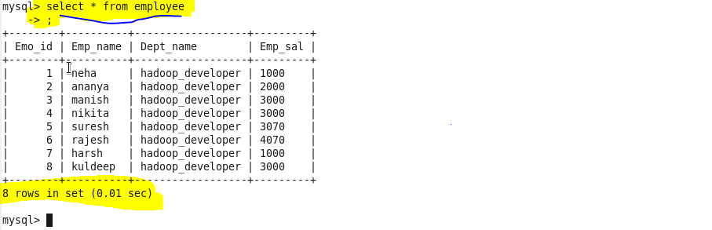

**SQOOP COMMAND TO DO IMPORT AND ITS EXPLANATION :**

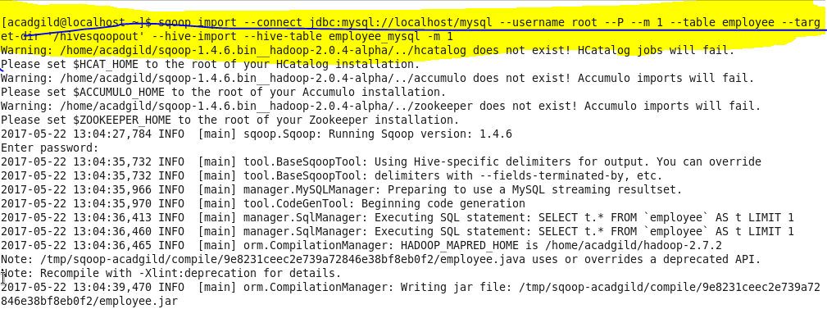

**From the below picture the table is successfully imported to HIive:**

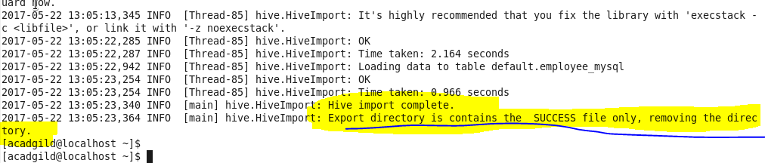

**OUTPUT:**

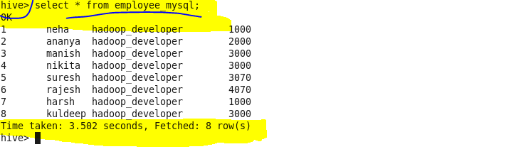

**INPUT:**

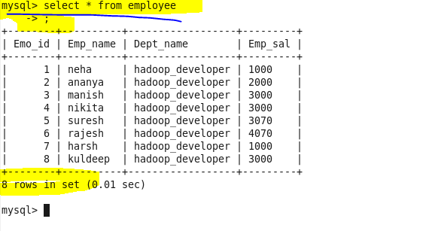

**Hbase as mysql_employee:**

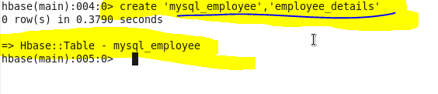

**SQOOP COMMAND TO DO IMPORT AND ITS EXPLANATION:**

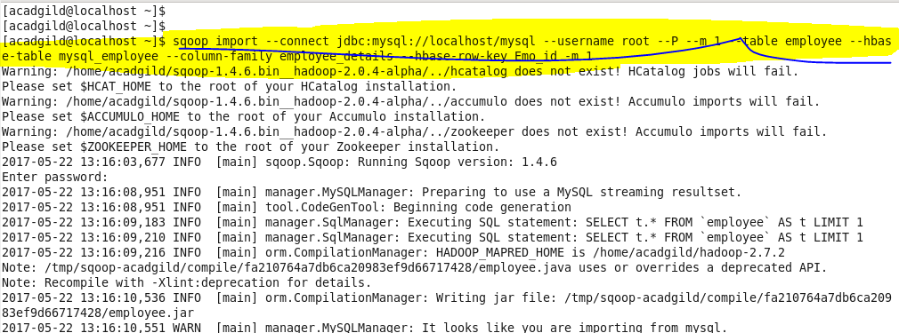

**From the above picture the table is successfully imported to Hbase:**

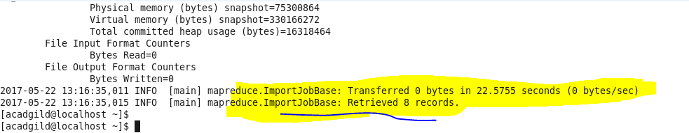

**OUTPUT:**

